User Manual MATLAB Based Optical Analysis Toolbox V 3.0

**Table of contents**

Cover Page 3

Objective 6

General Folder Structure 9

Starting the Toolbox 13

Setting up a New Optical System 17

Opening Optical Systems from File 20

Parent Window 23

Surface Editor Panel 26

System Configuration Panel 32

Menu Items 37

Children Windows 41

System Layout 44

2D System Layout Window 47

3D System Layout Window 50

Single Ray Tracing 53

Scalar Ray Trace 56

Polarization Ray Trace 60

Optical System Analysis 64

Paraxial Analysis 67

Transverse Ray Aberration 70

Longitudinal Aberration 73

Footprint Diagram 76

Pupil Apodization 79

Polarization Ellipse Map 82

Diffraction 85

Wavefront @ Exit Pupil 87

FFT PSF 90

Polarization Aberration: 94

Amplitude Transmission Map 97

Phase Map 100

Wavefront Diattenuation Map 103

Wavefront Retardation Map 106

Coating 109

New Coating Catalogue 112

Coating Data Editor 115

Coating Analysis 118

Refractive Index Profile 121

Coating Property Versus Incidence Angle 124

Coating Properties vs Wavelength 128

Glass 132

Glass Data Editor 135

New Glass Catalogue 138

Help 141

About 144

User Manual 147

Programming and Algorithms Reference 150

Source Code Viewer 153

**Cover Page**

MATLAB Based Optical System Analyzer Toolbox

User Manual Version 3.0

Optical System Design Research Group

Institute of Applied Physics

Friedrich Schiller University of Jena

05/23/2014

Norman G. Worku

Advisor: Prof. Dr. Herbert Gross

*Created with the Personal Edition of HelpNDoc:* [*Generate EPub eBooks with ease*](http://www.helpndoc.com/create-epub-ebooks)

**Objective**

# Objective

Optical System Analyzer Toolbox is a GUI based optical ray tracing toolbox in MATLAB, which is being designed by optical system design and simulation research group, Institute of Applied Physics, Friedrich Schiller University of Jena.

The objective of this document is to give a brief user manual for using the toolbox from its graphical user interface windows. Even though the functions and classes in the toolbox are commented and well documented, this document makes the toolbox more understandable and easy for future users and developers. The user interfaces and their functionalities are described in detail. But more technical and detailed programming reference is given in a separate document, the programming reference document.

Please send any comments, corrections or suggestions by email to **''Norman G. Worku <normangirma2012@gmail.com>"**. They shall be recorded and included in the next versions.

*Created with the Personal Edition of HelpNDoc:* [*Free Web Help generator*](http://www.helpndoc.com)

**General Folder Structure**

# General Folder Structure

All MATLAB codes for the toolbox are organized in to different folders based on their function. The main folder for the toolbox is "MATLAB Based Optical System Analyzer Toolbox 3.0 May 01 Working Version ". The following table summarized the folders with brief description.

|  |  |
| --- | --- |
| **Folder Name** | **Description** |
| Analysis_Module | It has all function which are used for analysis feature of the toolbox. |
| Catalogue_Files | Contains catalogue files used in the optical system. It is default folder for saving catlogue files. |
| Catalogue_Module | It contains functions used to manipulate all catlogue files, such adding new catalogue. |
| Class_Definition | This folder contains all class definitions with their functions. It contains class definitions for OpticalSystem, Glass, Coating, Ray, RayTraceResult, Surface and GUI class for ParentWindow and ChildWindows. |
| Coating_Catalogue_Module | It contains functions which are specifically used to manipulate coating catalogue such as function for GUI for editing coating data. |
| Command_Window_Functions | (Not used currently). To be used to define the Macro commands which can be used to used the toolbox from command window in addition to (together with) the GUI. |
| Database_Files | All database files used in the toolbox are placed here. |
| Diffraction_Module | It contains functions for wave optical and diffraction calculations. |
| Documentation_Module | It contains help files, user manuals, programming reference, scientific research papers and any other files which can be used as help for the toolbox. |
| Evaluation_Systems | Here sample systems to evaluate different features of the toolbox are saved. |
| Glass_Catalogue_Module | It contains functions which are specifically used to manipulate glass catalogue such as function for GUI for editing glass data. |
| GUI_Start_Up |  |
| Import_Export_Module | This folder has all the functions which can be used to perform importing and exporting data, catalogue files , ... between other exisitng formats and the format which is used in the toolbox. |
| Internship Report and Presentation |  |
| Mathematical_Functions | This folder is Maths module of the toolbox containing all mathematical functions used in the toolbox. |
| Meridional_Optics_Module | Contains functions to perform meridional ray tracing. |
| Others | It contains all archived functions which are no longer used in the toolbox. |
| Paraxial_Optics_Module | In this folder functions for paraxial ray tracing and related analysis are saved. |
| Polarization_Ray_Tracing_Module | Contains functions used for polarization ray tracing. |
| RLW Progress Test Scripts |  |
| Scalar_Ray_Tracing_Module | Functions used to perform scalar ray tracing such as finding intersection points are saved in this folder. |
| Test_Scripts | It contains matlab scripts which are used to test the toolbox from command window. |
| Unclassified_Tools_Module | All functions and scripts which doesn't belong to any of the above folders are put here. |

*Created with the Personal Edition of HelpNDoc:* [*Generate EPub eBooks with ease*](http://www.helpndoc.com/create-epub-ebooks)

**Starting the Toolbox**

# Starting the Toolbox

For MATLAB 2012b or latest users, the toolbox is deployed as a MATLAB app, which is a single file that can be installed to App gallery of MATLAB. All issues regarding the path and working directory are handled automatically. So to start using the toolbox,

* Install the app, which is done just by opening the installable file.
* Start the toolbox by clicking on the App from the App gallery in MATLAB.
* Once installed and started the toolbox can be used from the MATLAB Command Window
  + Use the function names directly in the command window.

**Note:** All the source files and the different modules of the toolbox can be seen by browsing through the folder where the App is installed.

For users of earlier versions of MATLAB, the toolbox folder shall be copied to the destination computer. And then the toolbox can be used from either from the GUI or the command window as follows.

1. Using from the GUI Windows
   * Include the Toolbox main folder with all of its sub folders to the current working directory of the MATLAB.
   * Make the Toolbox main folder your current directory.
   * To open the main GUI window of the toolbox, write 'AODStartup' in the MATLAB command window.
   * Then use the using the GUI to set up and analyze an optical system.
2. Using form MATLAB Command Window
   * Include the Toolbox main folder with all of its sub folders to the current working directory of the MATLAB.
   * Use the function names directly.

This user manual is used for the GUI based operation of the toolbox. The command based operation will be included in the future.

**Note:** As the toolbox uses 'pwd' commands to get the toolbox directory, it is must to make the toolbox folder current working folder otherwise some features may fail. Your current directory should be as shown below

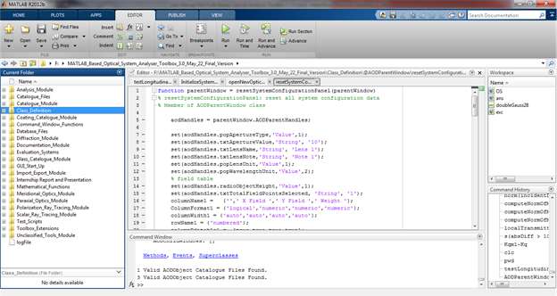

*Created with the Personal Edition of HelpNDoc:* [*Free HTML Help documentation generator*](http://www.helpndoc.com)

**Setting up a New Optical System**

**Setting up a New Optical System**

To set up a new optical system system using the GUI of the toolbox,

1. Start the main parent GUI (see section "Starting the Toolbox" for detail steps.)
2. Start entering the surface data in the surface data editor of the parent GUI.
   * To Add a New Surface:
     + Select the "Standard Data" tab of the surface data editor.
     + Select the first column of the row where a new surface is to be added.
     + Click the plus (+) button from the toolbar.
     + **Note:** Surface can not be added in the row 1 (reserved for Object)
   * To Remove a Surface:
     + Select the "Standard Data" tab of the surface data editor.
     + Select the first column of the surface which is to be deleted.
     + Click the minus (-) button from the toolbar.
     + **Note:** First and Last surfaces can not be removed.
   * To Set a Surface as Stop:
     + Select the "Standard Data" tab of the surface data editor.
     + Select and write "Stop" in the first column of the surface which is to be set as "Stop".
3. Enter all system configuration data otherwise the default values will be used.
4. Finally Save the system.

*Created with the Personal Edition of HelpNDoc:* [*Full-featured Documentation generator*](http://www.helpndoc.com)

**Opening Optical Systems from File**

**Opening Optical Systems from File**

The toolbox supports saving an optical systems to file which can be opened when required. To open an optical system:

1. Click on File >> Open
2. Choose a valid optical system file (.mat file) from the open dialog box.
3. Click Ok then the system will be loaded to the parent GUI.

*Created with the Personal Edition of HelpNDoc:* [*Generate EPub eBooks with ease*](http://www.helpndoc.com/create-epub-ebooks)

**Parent Window**

**Parent Window**

Writing "AODParentWindow" in the command window starts the main GUI of the toolbox shown below.

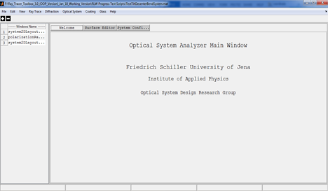

The main window has the following main parts:

* **Title Bar:**
  + The full path name of the current optical system is displayed.
* **Menu Bar:**
  + It contains Menu items which are used to use different features of the toolbox.
  + For detailed description see the "Menu Bar" section below.
* **Tool Bar:**
  + Contains buttons for frequently used features of the toolbox. It acts as shortcuts to the menu items.
* **Opened Window List Panel:**
  + It is panel to the left side of the window and displays the list of all currently opened child windows. This allows access of the child windows just a click away in case of working with multiple child windows.
* **Main Panel:**
  + It is the largest part of the main window where the following panels are displayed:
    - **Welcome Panel:** Display welcome message.
    - **Surface Editor Panel:** Contains tabbed surface data editors.
    - **System Configuration Panel:** Has tabbed windows for inputting system configurations.
* **Status Bar:** 
  + It is at the bottom of the window and used to display important information of the current optical system.

*Created with the Personal Edition of HelpNDoc:* [*Easily create Web Help sites*](http://www.helpndoc.com/feature-tour)

**Surface Editor Panel**

**Surface Editor Panel**

It is part of the main panel of the parent window and contains spreadsheet like data editors for entering and editing the surface data of an optical system.

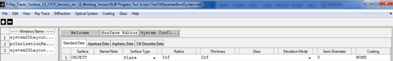

It is organized in to different tabs: Standard data, Aperture Data, Aspheric Data, and Tilt and Decenter Data. Each of the tabs are discussed below.

**1. Standard Data**

It contains surface data which are required for conventional optical systems.

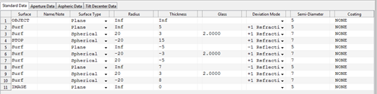

|  |  |  |
| --- | --- | --- |
| **Column Header** | **Description** | **Remarks** |
| Surface | Used to indicate the surface index or whether the surface is object or, image or stop surface or not. | Object and image surfaces are always the first and the last surfaces of the system.  To make a surface a stop, type “s” or “stop” in the surface column.  Any text inputs other than “s” or “stop” will be rejected by the system |
| Name/Comment | To enter name and notes related to the surface. | Any text inputs are accepted and it has no real functional significance. |
| Surface Type | A pop up menu to choose the type of surface. | Currently Plane, Spherical, and Conic Aspherical surfaces are functional. Other surface types are to be included in the future. |
| Radius | Used to input the radius of curvature of the surface. The unit of the number will be that specified in the “System Configuration” window. | All numeric values including 0 and Inf are accepted by the system. Other inputs are not allowed. The surface type and radius fields are interlinked and changing one automatically affects the other. For instance, selecting plane surface for the surface type automatically sets the radius to infinity. And changing the radius to some finite value changes the surface type to Spherical if it is Plane. |
| Thickness | To enter the thickness the medium that follows the current surface. The unit of the number will be that specified in the “System Configuration” window. | All numeric values including 0 and Inf are accepted by the system. Other inputs are not allowed. But entering Inf thickness for surfaces other than the object surface and the last surface of the system will result in an invalid optical system. |
| Glass | To enter the glass name or the refractive index of the medium that follows the current surface. | Any number value is treated as refractive index of the medium. And any non-numerical text will be treated as the name of the glass from glass catalogue. If the glass name entered exists in the catalogue, it will be confirmed by changing the entered text to upper case. If the system fails to find the glass name entered then, the Glass data editor window will automatically appear to enable user select or enter the new glass. |
| Deviation Mode | Pop up menu used to indicate the surface as reflective (-1) or refractive (+1). |  |
| Semi diameter | Define the semi diameter of the surface. | This is linked with the surface aperture definition spreadsheet. If the surface aperture type is “None” and some value is entered for semi diameter then, the aperture type will automatically be changed to circular with radius equal to the semi diameter entered. But if the surface has its aperture defined, then the semi diameter will only be used to plot the surface and not for aperture calculations. |
| Coating | Name of coating used. "None" for bare glass. | Any non-numerical text will be treated as the name of the glass from coating catalogue. If the coating name entered exists in the catalogue, it will be confirmed by changing the entered text to upper case. If the system fails to find the coating name entered then, the Coating data editor window will automatically appear to enable user select or enter the new coating. |

Notes:

Unlike most optical design softwares, the object surface is considered to be the first surface in the toolbox. This is follows from the fact that indexing begins from index 1 in Matlab.

**2. Aperture Data**

It contains data defining surface apertures.

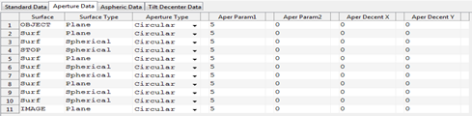

|  |  |  |
| --- | --- | --- |
| **Column Header** | **Description** | **Remarks** |
| Surface | See “standard data” sheet | Just repeated from standard data entry sheet for surface identification. |
| Surface Type | See “standard data” sheet | Just repeated from standard data entry sheet for surface identification. |
| Aperture Type | Pop up menu to select the type of aperture used for the surface | Currently “Circular” , "Elliptical"and “Rectangular” aperture shapes are functional. Others are left for future versions. |
| Aperture Param 1 | Aperture Parameter | Only positive numerical values are allowed. It has different purpose for different aperture types.  Radius for circular aperture and x side length for rectangular. |
| Aperture Param 2 | Aperture Parameter | Only positive numerical values are allowed. Not applied for circular and y side length for rectangular. |
| Aper Decenter X | Aperture Decenter in X | Not functional |
| Aper Decenter Y | Aperture Decenter in Y | Not functional |

**3. Aspheric Data**

It contains data defining aspherical surfaces such as aspheric constants and polynomial coefficients.

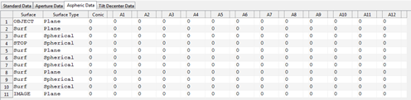

|  |  |  |
| --- | --- | --- |
| **Column Header** | **Description** | **Remarks** |
| Surface | See “standard data” sheet | Just repeated from standard data entry sheet for surface identification. |
| Surface Type | See “standard data” sheet | Just repeated from standard data entry sheet for surface identification. |
| Conic | To enter the conic constant of the surface. | This is used for surface types indicated to be aspherical in the standard data entry. If the surface type is not aspheric then the conic constant will automatically be 0. |
| A1…A12 | Polynomial Coefficients | Not functional |

**4. Tilt and Decenter Data**

It includes tilt and decenter parameters of the surfaces.

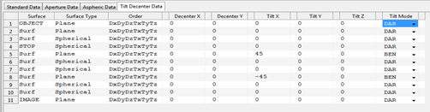

|  |  |  |
| --- | --- | --- |
| **Column Header** | **Description** | **Remarks** |
| Surface | See “standard data” sheet | Just repeated from standard data entry sheet for surface identification. |
| Surface Type | See “standard data” sheet | Just repeated from standard data entry sheet for surface identification. |
| Order | Order in which tilt and decenter are performed. | All the tilt and decenter operations shall be listed otherwise it will be invalid. |
| Decenter X,Y | Surface decenter in X and Y coordinate | Non infinite numeric values are allowed. |
| Tilt X,Y,Z | Tilt angle (in deg) about the corresponding axes. | Currently they are used as successive rotation angles in degrees. |
| Tilt Mode | Pop up menu for selecting the mode of the tilt determining the reference coordinate axis after the current surface. |  |

*Created with the Personal Edition of HelpNDoc:* [*Easy EBook and documentation generator*](http://www.helpndoc.com)

**System Configuration Panel**

**System Configuration Panel**

It is part of the main panel of the parent window and contains tabbed windows for entering and editing the system configuration data of an optical system.

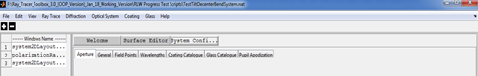

In the following section each tabbed windows will be briefly discussed.

**1. Aperture**

Define system aperture. System aperture can be specified by either Entrance Pupil Diameter or Object Space NA. All other methods of system aperture specifications are left for the future. For objects at finite distance both can be used whereas for infinite objects, the object space numerical aperture is not defined and so it cannot be set in the aperture window.

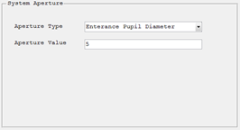

**2. General**

Here the general information relating the current optical system can be entered or modified including the units used for the lens and wavelength measurements.

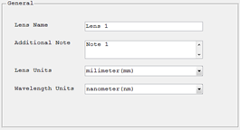

**3. Field Points**

To define set of field points, which can later be used to analyze the system. Field points can be defined either by specifying the object height or by ray angles. If object heights are used to define the field points, the heights are measured in lens units. Field angles are always in degrees. The angles are measured with respect to the object space z axis and the paraxial entrance pupil position on the object space z axis. Like in Zemax, x field angles and y field angles can be converted to ray direction cosines using the following formulas:

tan (Fx) = l/n

tan (Fy) = m/n

l2+m2+n2 = 1

Where l,m and n are the x,y and z direction cosines.

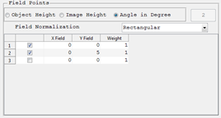

**4. Wavelengths**

To define wavelengths which the system can use for different analysis.The weight related to each wavelength values are not functional for current version. And the units of the wavelength specified are in the general tab. Predefined wavelengths can also be selected directly.

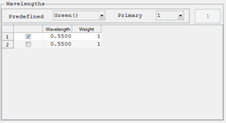

**5. Coating Catalogue**

List of all coating cataloogue used in the optical system. They can be deselected to remove from the used catalogue list. When optical system is saved those only selected ones will be saved as used coating catalogues. A new catalogue can also be added to the list. If the new catalogue added is not in the default catalogue files folder of the toolbox it will be automatically copied to that folder. Only those selected catalogues are cosidered during caoting analysis.

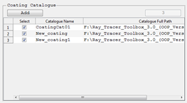

**6. Glass Catalogue**

List of all glass cataloogue used in the optical system. They can be deselected to remove from the used catalogue list. When optical system is saved those only selected ones will be saved as used glass catalogues. A new catalogue can also be added to the list. If the new catalogue added is not in the default catalogue files folder of the toolbox it will be automatically copied to that folder. Only those selected catalogues are cosidered during glass analysis.

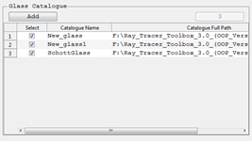

**7. Pupil Apodization**

It is used to define the pupil apodization to be used in the system to simulate the effect of non-uniform illumination. Currently only uniform and super-gaussian profiles are supported.

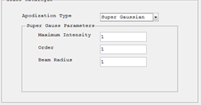

*Created with the Personal Edition of HelpNDoc:* [*Easy to use tool to create HTML Help files and Help web sites*](http://www.helpndoc.com/help-authoring-tool)

**Menu Items**

**Menu Items**

The general structure of the menu items in the menu bar is shown here.

* **File:** 
  + **New:** Opens new surface editor window resetting all the parent window and closing all child windows.
  + **Open:** Opens Windows “Open File” dialog box which can be used to open previously saved optical systems by the toolbox.
  + **Save:** Saves any changes on the current optical system to the current file name or opens Windows “Save As” dialog box if the system is not yet saved.
  + **Save As:** Opens Windows “Save As” dialog box which enables saving current optical system to a .mat file in a user defined location.
  + **Close:** Closes the application.
* **Edit:** 
  + **Surface Editor:** Opens the “Surface Editor” panel for current optical system.
  + **System Configuration:** Opens the “Optical System Configuration” panel.
* **Ray Tracing:** 
  + **Scalar Ray Trace:** Opens single ray data entry window which enables tracing of a single ray through current optical system.
  + **Polarization Ray trace:** Opens single polarized ray data entry window which enables polarization ray tracing of a single ray through current optical system.
* **View:** 
  + **2D System Layout:** Plots the two dimensional cross sectional view of rotationally symmetric optical systems.
  + **3D System Layout:** Plots the three dimensional system layout for general optical systems.
* **Optical System:**
  + **Optical System Analysis:**
    - **Footprint Diagram:** Plots footprint diagram of a bundle of ray on a given surface of an optical system.
    - **Polarization Ellipse Map:** Shows distribution of polarization ellipse over the pupil area for a given polarized ray at a given surface.
    - **Paraxial Analysis:** Performs paraxial analysis and displays the result in the command window.
    - **Transverse Ray Aberration:** Plots the transverse ray aberration with respect to the chief ray.
    - **Polarization Aberration:** Displays different graphs showing the polarization aberration of the optical system.
* **Diffraction:**
  + **Wavefront @ Exit Pupil:** Computes and displays the wavefront surface which corresponds to OPD surface at exit pupil.
  + **Pupil Apodization:** Displays graphical apodization profile of the current system.
  + **FFT PSF:** Computes Fast Fourier Transform based point spread function for a given optical system.
* **Coating:** 
  + **Coating Data Editor:** Displays a window that enables to see, edit, add or remove coating from the coating catalogues used in the current optical system.
  + **Coating Analysis:** Displays different graphs to analyze any coating in the coating catalogue.
  + **Coating Catalogue:**
    - **New Coating Catalogue:** Adds new empty coating catalogue to the default catalogue file folder.
* **Glass:** 
  + **Glass Data Editor:** Displays a window that enables to see, edit, add or remove glass from the glass catalogues used in the current optical system.
  + **Glass Catalogue:**
    - **New Glass Catalogue:** Adds new empty glass catalogue to the default catalogue file folder.
    - **Import Glass Catalogue:**
      * Import glass from other formats. Currently Schott catalogue on excel format are supported but in the future more formats shall be defined.
* **Help:**
  + **About:** Short description of the toolbox.
  + **User Manual:** Open the electronic form of the user manual.
  + **Programming Reference:** Open the programming reference document for the toolbox.

*Created with the Personal Edition of HelpNDoc:* [*Full-featured EBook editor*](http://www.helpndoc.com/create-epub-ebooks)

**Children Windows**

**Children Windows**

Children windows are those windows which are displayed on request and are used to perform some analysis on the optical system or other optical components. All the children windows are made to have the same format in order to keep consistency throughout the toolbox. All windows have got four tabs as shown below.



* **Setting Tab:** 
  + Contains all the input settings for the analysis to be performed.
  + Almost all analysis windows have setting parameters.
* **Graph Tab:**
  + Displays the graphical results for analysis having graphical output.
  + Most analysis have graphical results.
* **Text Tab:** 
  + Displays the Text results for analysis having Text output.
  + Some analysis features such as single ray trace have text results.
* **Table Tab:**
  + Displays the tabular results for analysis having tabular output.
  + Used for displaying the x and y axis numerical values for 2D graphical results.

*Created with the Personal Edition of HelpNDoc:* [*Easily create PDF Help documents*](http://www.helpndoc.com/feature-tour)

**System Layout**

**System Layout Windows**

Display the 2D and 3D system layout windows for the given optical system.

*Created with the Personal Edition of HelpNDoc:* [*Free help authoring environment*](http://www.helpndoc.com/help-authoring-tool)

**2D System Layout Window**

**2D System Layout Window**

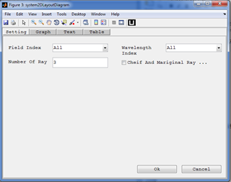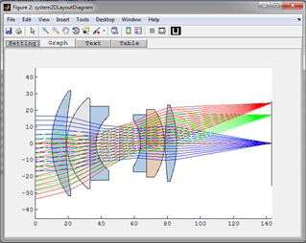

**Purpose:**

Display 2D layout diagram of the optical system. It shows the y-z cross section of the system.

**Setting:**

|  |  |  |
| --- | --- | --- |
| **Settings** | **Description** | **Remarks** |
| Field Index | Index of the field value for the rays to be displayed in the layout. | All fields can be used at the same time. |
| Wavelength Index | Index of the wavelength value for the rays to be displayed in the layout. | All wavelengths can be used at the same time. |
| Number of Rays | The number of rays to be traced per each field point and each wavelength. | Number less than 3 is not recommended. |
| Chief and Marginal Ray | Limits the number of rays to just 3 corresponding to the two marginal rays and a chief ray. |  |

*Created with the Personal Edition of HelpNDoc:* [*Free help authoring tool*](http://www.helpndoc.com/help-authoring-tool)

**3D System Layout Window**

**3D System Layout Window**

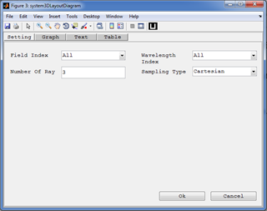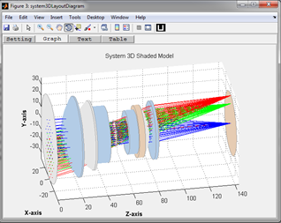

**Purpose:**

Display 3D layout diagram of the optical system. It shows the y-z cross section of the system.

**Setting:**

|  |  |  |
| --- | --- | --- |
| **Settings** | **Description** | **Remarks** |
| Field Index | Index of the field value for the rays to be displayed in the layout. | All fields can be used at the same time. |
| Wavelength Index | Index of the wavelength value for the rays to be displayed in the layout. | All wavelengths can be used at the same time. |
| Number of Rays | The number of rays to be traced per each field point and each wavelength. | Number less than 3 is not recommended. |
| Sampling Type | Select the sampling types to be used for pupil. | Currently supported: Cartesian, Tangential, Sagital, and Random sampling. All others are treated as Cartesian. |

*Created with the Personal Edition of HelpNDoc:* [*Full-featured multi-format Help generator*](http://www.helpndoc.com/help-authoring-tool)

**Single Ray Tracing**

**Single Ray Trace**

It is feature of the toolbox which allows tracing of a single ray through the system with or without polarization consideration. A single ray in an optical system can be defined using the relative definition specifying the normalized coordinates/angles of the field point and normalized coordinate of the pupil point where the ray crosses the entrance pupil. The position and direction of the ray can then be computed following the following algorithm:

For polarized ray trace, the initial polarization state shall be specified using the initial Jones vector. The

*Created with the Personal Edition of HelpNDoc:* [*Free Web Help generator*](http://www.helpndoc.com)

**Scalar Ray Trace**

**Scalar Ray Trace**

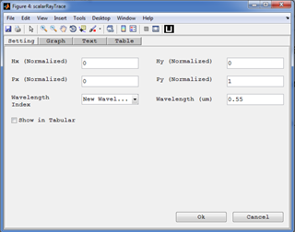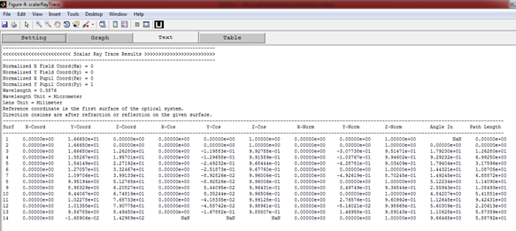

**Purpose:**

To see the real scalar ray trace results for single ray.

**Setting:**

|  |  |  |
| --- | --- | --- |
| **Settings** | **Description** | **Remarks** |
| Hx(Normalized) ,Hy(Normalized) | Normalized values for field coordinates/angles in the object space. | Valid values [-1,1] |
| Px(Normalized) ,Py(Normalized) | Normalized values for pupil coordinates at the entrance pupil. | Valid values [-1,1] |
| Wavelength Index | Index of the wavelength value for the ray. | A single index should be selected. But new wavelengths can also be used. |
| Wavelength | The wavelength to be used for the ray trace in micrometer. | If "New Wavelength" is selected for a wavelength index, the new wavelength should be specified here in micrometer. |
| Show in Tabular | Display the result in tabular format as in Zemax. | If deselected, the ray trace results will be displayed in a text format giving the results in surface to surface sequence. |

*Created with the Personal Edition of HelpNDoc:* [*Free help authoring tool*](http://www.helpndoc.com/help-authoring-tool)

**Polarization Ray Trace**

**Polarization Ray Trace**

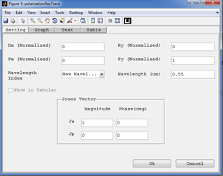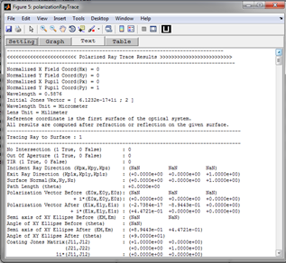

**Purpose:**

To see the real polarization ray trace results for single ray.

**Setting:**

|  |  |  |
| --- | --- | --- |
| **Settings** | **Description** | **Remarks** |
| Hx(Normalized) ,Hy(Normalized) | Normalized values for field coordinates/angles in the object space. | Valid values [-1,1] |
| Px(Normalized) ,Py(Normalized) | Normalized values for pupil coordinates at the entrance pupil. | Valid values [-1,1] |
| Wavelength Index | Index of the wavelength value for the ray. | A single index should be selected. But new wavelengths can also be used. |
| Wavelength | The wavelength to be used for the ray trace in micrometer. | If "New Wavelength" is selected for a wavelength index, the new wavelength should be specified here in micrometer. |
| Jones Vector | Defines the initial polarization vector of the ray. It is given in s-p-k coordinate system which is not the same as the global x-y-z coordinate in many cases. | The phase values of Jones vector are always given in degrees. |

*Created with the Personal Edition of HelpNDoc:* [*Easily create EBooks*](http://www.helpndoc.com/feature-tour)

**Optical System Analysis**

**Optical System Analysis**

Here all analysis features of the toolbox are described.

*Created with the Personal Edition of HelpNDoc:* [*Write eBooks for the Kindle*](http://www.helpndoc.com/feature-tour/create-ebooks-for-amazon-kindle)

**Paraxial Analysis**

**Paraxial Analysis**

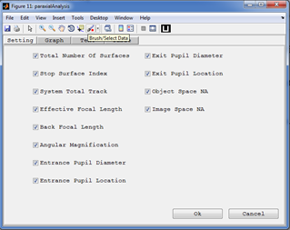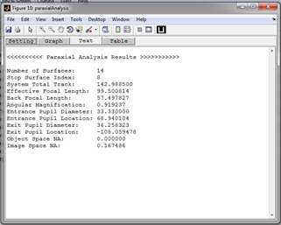

**Purpose:**

Performs paraxial analysis and displays the result in the command window.

**Setting:**

Select the paraxial/gaussian parameter of the optical system to compute.

*Created with the Personal Edition of HelpNDoc:* [*Easily create PDF Help documents*](http://www.helpndoc.com/feature-tour)

**Transverse Ray Aberration**

**Polarization Ellipse Map**

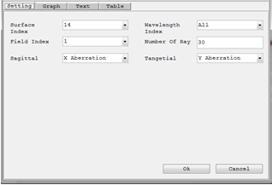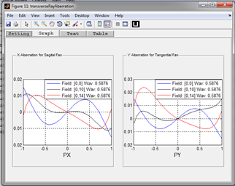

**Purpose:**

Display graphs showing the transverse aberration (in X or Y) of sagittal or tangential rays with respect to the cheif ray at a given surface.

**Setting:**

|  |  |
| --- | --- |
| **Settings** | **Description** |
| Surface Index | The surface index used to compute the transverse aberration. |
| Field Index | Index of the field value for the analysis. |
| Wavelength Index | Index of the wavelength value for the analysis. |
| Number of Rays | The number of rays to be traced per each field point and each wavelength. |
| Sagittal | Selects which aberration component to plot for the sagittal fan. |
| Tangential | Selects which aberration component to plot for the tangential fan. |

*Created with the Personal Edition of HelpNDoc:* [*Full-featured EBook editor*](http://www.helpndoc.com/create-epub-ebooks)

**Longitudinal Aberration**

**Longitudinal Aberration Diagram**

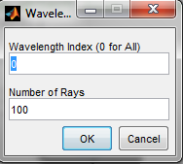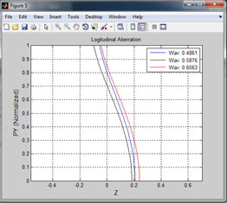

**Purpose:**

An analysis window (added as an external extension to the toolbox - As an example) which displays the longitudinal aberration as a function of pupil height at each wavelength.

**Setting:**

|  |  |
| --- | --- |
| **Settings** | **Description** |
| Wavelength Index | Index of the wavelength value for the analysis. |
| Number of Rays | The number of rays to be traced per each field point and each wavelength. |

*Created with the Personal Edition of HelpNDoc:* [*Free help authoring environment*](http://www.helpndoc.com/help-authoring-tool)

**Footprint Diagram**

**Footprint Diagram**

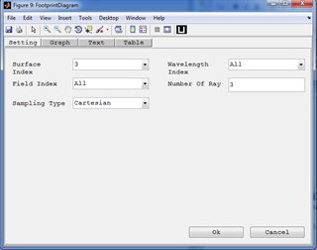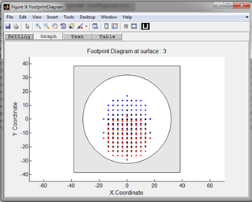

**Purpose:**

Display the footprint diagram of the optical system at a given surface.

**Setting:**

|  |  |  |
| --- | --- | --- |
| **Settings** | **Description** | **Remarks** |
| Surface Index | The surface index used to view the footprint diagram. |  |
| Field Index | Index of the field value for the rays to be displayed in the layout. | All fields can be used at the same time. |
| Wavelength Index | Index of the wavelength value for the rays to be displayed in the layout. | All wavelengths can be used at the same time. |
| Number of Rays | The number of rays to be traced per each field point and each wavelength. | Number less than 3 is not recommended. |
| Sampling Type | Select the sampling types to be used for pupil. | Currently supported: Cartesian, Tangential, Sagital, and Random sampling. All others are treated as Cartesian. |

*Created with the Personal Edition of HelpNDoc:* [*Full-featured Documentation generator*](http://www.helpndoc.com)

**Pupil Apodization**

**Pupil Apodization**

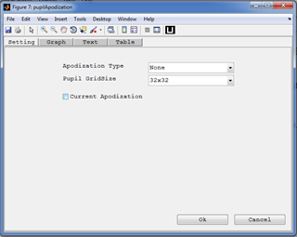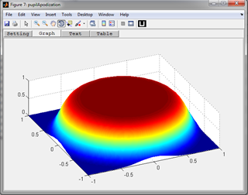

**Purpose:**

Display the pupil apodization profile used for the system. It can also be used to show any profiles possible in the toolbox.

**Setting:**

|  |  |  |
| --- | --- | --- |
| **Settings** | **Description** | **Remarks** |
| Apodization Type | Select the type of apodization profile to view. Different parameter entry windows will be displayed depending on the type selected. | Currently only uniform and super gaussian profile is supported. |
| Pupil Grid Size | The sampling grid size of the entrance pupil. | Pupil sampling type is Cartesian. |
| Current Apodization | Fixes the apodization type and parameters to the one used by the current optical system. |  |

*Created with the Personal Edition of HelpNDoc:* [*Easily create EPub books*](http://www.helpndoc.com/feature-tour)

**Polarization Ellipse Map**

**Polarization Ellipse Map**

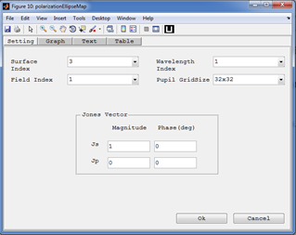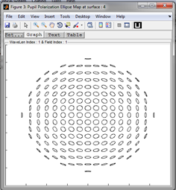

**Purpose:**

Display the pupil polarization map of the system for a given initial polarization over the pupil at a given surface. It just displays the map in the x-y plane considering the Ex and Ey.

**Setting:**

|  |  |  |
| --- | --- | --- |
| **Settings** | **Description** | **Remarks** |
| Surface Index | The surface index used to view the footprint diagram. |  |
| Field Index | Index of the field value for the rays to be displayed in the layout. | A single index should be selected. |
| Wavelength Index | Index of the wavelength value for the rays to be displayed in the layout. | A single index should be selected. |
| Pupil Grid Size | The sampling grid size of the entrance pupil. |  |
| Jones Vector | Defines the initial polarization vector of the ray. It is given in s-p-k coordinate system which is not the same as the global x-y-z coordinate in many cases. | The phase values of Jones vector are always given in degrees. |

*Created with the Personal Edition of HelpNDoc:* [*Write eBooks for the Kindle*](http://www.helpndoc.com/feature-tour/create-ebooks-for-amazon-kindle)

**Diffraction**

*Created with the Personal Edition of HelpNDoc:* [*Easily create EBooks*](http://www.helpndoc.com/feature-tour)

**Wavefront @ Exit Pupil**

**Wavefront @ Exit Pupil**

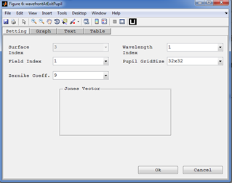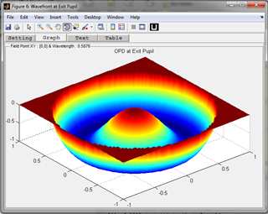

**Purpose:**

Display the wavefront error surface at the exit pupil. It corresponds to the optical path difference (OPD) all rays with respect to the chief ray at the exit pupil.

**Setting:**

|  |  |  |
| --- | --- | --- |
| **Settings** | **Description** | **Remarks** |
| Surface Index | The surface index used to compute the OPD. | Currently it is not functional and set fixed to the image surface. |
| Field Index | Index of the field value for the rays to be displayed in the layout. | A single index should be selected. |
| Wavelength Index | Index of the wavelength value for the rays to be displayed in the layout. | A single index should be selected. |
| Zernike coefficients. | The number of Zernike polynomials used for surface fitting. | Maximum of 64 coefficients can be computed. |
| Pupil Grid size | The sampling grid size of the entrance pupil. | Pupil sampling type is Cartesian. |

*Created with the Personal Edition of HelpNDoc:* [*Free Web Help generator*](http://www.helpndoc.com)

**FFT PSF**

**FFT PSF**

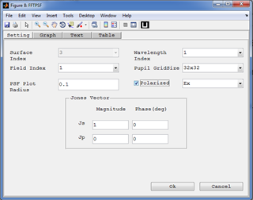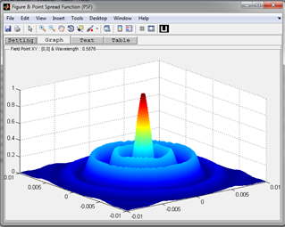

**Purpose:**

Display the point spread function of the system. It is based on the chirp Z-transform FFT algorithm.

**Setting:**

|  |  |  |
| --- | --- | --- |
| **Settings** | **Description** | **Remarks** |
| Surface Index | The surface index used to compute the OPD. | Currently it is not functional and set fixed to the image surface. |
| Field Index | Index of the field value for the rays to be displayed in the layout. | A single index should be selected. |
| Wavelength Index | Index of the wavelength value for the rays to be displayed in the layout. | A single index should be selected. |
| PSF plot radius. | Specify the radius required for the PSF plot. Changes the sampling distance in the focal plane. | CZT FFT allows the decoupling of the sampling in the pupil plane from that in the focal plane. |
| Pupil Grid Size | The sampling grid size of the entrance pupil. |  |
| Polarized (check box) | Compute the PSF for the selected component using scalar diffraction. | Allows to account for effects of coating in the PSF. |
| Polarized (drop down) | Select the field component used for the PSF computation. | Sum of the components is also allowed which simply means the incoherent sum of each PSF. |

*Created with the Personal Edition of HelpNDoc:* [*Single source CHM, PDF, DOC and HTML Help creation*](http://www.helpndoc.com/help-authoring-tool)

**Polarization Aberration:**

**Polarization Aberration**

Polarization aberration function represent variation of polarization ray tracing matrix of the system (which represents the polarization property of the system) over the pupil area. It can be used to analyze the polarization property of an optical system by plotting polarization dependent properties of the system over the pupil area. The following plots are used to analyze that. They are all derived from the polarization aberration function:

* **Amplitude Transmission Map:**
* **Phase Map:**
* **Wavefront Diattenuation Map:**
* **Wavefront Retardation Map:**

*Created with the Personal Edition of HelpNDoc:* [*Easily create HTML Help documents*](http://www.helpndoc.com/feature-tour)

**Amplitude Transmission Map**

**Amplitude Transmission Map**

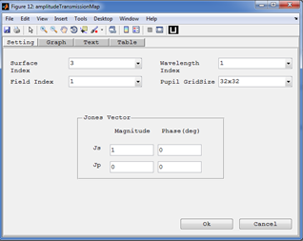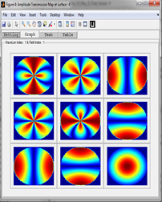

**Purpose:**

Plot of the amplitude part of the total polarization ray tracing matrix at different pupil locations. It is a 3X3 matrix of color plots.

**Setting:**

|  |  |  |
| --- | --- | --- |
| **Settings** | **Description** | **Remarks** |
| Surface Index | The surface index used to view the footprint diagram. |  |
| Field Index | Index of the field value for the rays to be displayed in the layout. | A single index should be selected. |
| Wavelength Index | Index of the wavelength value for the rays to be displayed in the layout. | A single index should be selected. |
| Pupil Grid Size | The sampling grid size of the entrance pupil. |  |
| Jones Vector | Defines the initial polarization vector of the ray. It is given in s-p-k coordinate system which is not the same as the global x-y-z coordinate in many cases. | The phase values of Jones vector are always given in degrees. |

*Created with the Personal Edition of HelpNDoc:* [*Generate EPub eBooks with ease*](http://www.helpndoc.com/create-epub-ebooks)

**Phase Map**

**Phase Map**

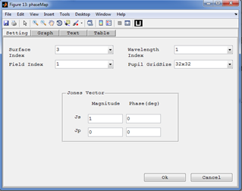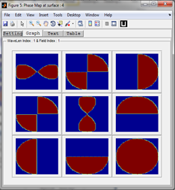

**Purpose:**

Plot of the phase part of the total polarization ray tracing matrix at different pupil locations. It can show the phase variation in range of one wave limit. It is a 3X3 matrix of color plots and it has setting parameters similar to amplitude transmission map.

**Setting:**

|  |  |  |
| --- | --- | --- |
| **Settings** | **Description** | **Remarks** |
| Surface Index | The surface index used to view the footprint diagram. |  |
| Field Index | Index of the field value for the rays to be displayed in the layout. | A single index should be selected. |
| Wavelength Index | Index of the wavelength value for the rays to be displayed in the layout. | A single index should be selected. |
| Pupil Grid Size | The sampling grid size of the entrance pupil. |  |
| Jones Vector | Defines the initial polarization vector of the ray. It is given in s-p-k coordinate system which is not the same as the global x-y-z coordinate in many cases. | The phase values of Jones vector are always given in degrees. |

*Created with the Personal Edition of HelpNDoc:* [*Easily create Help documents*](http://www.helpndoc.com/feature-tour)

**Wavefront Diattenuation Map**

**Wavefront Diattenuation Map**

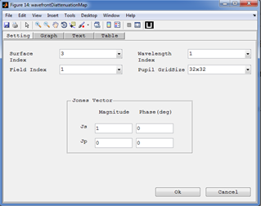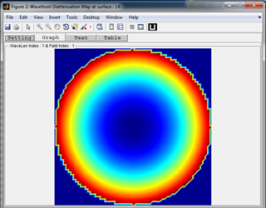

**Purpose:**

Plot of the diattenuation related to the total polarization ray tracing matrix at different pupil locations. It is a polarization dependent apodization map. It is a single color map showing diattenuation related to the total polarization ray tracing matrix over the pupil coordinates.

**Setting:**

|  |  |  |
| --- | --- | --- |
| **Settings** | **Description** | **Remarks** |
| Surface Index | The surface index used to view the footprint diagram. |  |
| Field Index | Index of the field value for the rays to be displayed in the layout. | A single index should be selected. |
| Wavelength Index | Index of the wavelength value for the rays to be displayed in the layout. | A single index should be selected. |
| Pupil Grid Size | The sampling grid size of the entrance pupil. |  |
| Jones Vector | Defines the initial polarization vector of the ray. It is given in s-p-k coordinate system which is not the same as the global x-y-z coordinate in many cases. | The phase values of Jones vector are always given in degrees. |

*Created with the Personal Edition of HelpNDoc:* [*Free iPhone documentation generator*](http://www.helpndoc.com/feature-tour/iphone-website-generation)

**Wavefront Retardation Map**

**Wavefront Retardation Map**

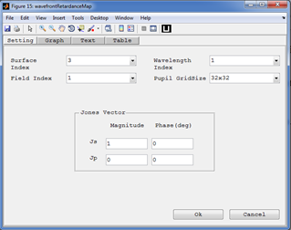

**Purpose:**

Plot of the retardance related to the total polarization ray tracing matrix at different pupil locations. . It is a polarization dependent optical path difference (OPD) map. It is a single color map showing retardance related to the total polarization ray tracing matrix over the pupil coordinates.

**Setting:**

|  |  |  |
| --- | --- | --- |
| **Settings** | **Description** | **Remarks** |
| Surface Index | The surface index used to view the footprint diagram. |  |
| Field Index | Index of the field value for the rays to be displayed in the layout. | A single index should be selected. |
| Wavelength Index | Index of the wavelength value for the rays to be displayed in the layout. | A single index should be selected. |
| Pupil Grid Size | The sampling grid size of the entrance pupil. |  |
| Jones Vector | Defines the initial polarization vector of the ray. It is given in s-p-k coordinate system which is not the same as the global x-y-z coordinate in many cases. | The phase values of Jones vector are always given in degrees. |

*Created with the Personal Edition of HelpNDoc:* [*Easy CHM and documentation editor*](http://www.helpndoc.com)

**Coating**

**Coating**

In the toolbox the coating parameter can be:

* **None:** The coating is just ignored and the corresponding jones matrix would be a 2x2 unity.
* **Bare:** The Jones matrix is computed from the Fresnels coefficients for bare glass or a single interface would be used.
* **A multilayer coating:**  The Jones matrix is computed from the Fresnels coefficients for multilayer interface would be used.

All coating will be stored in coating catalogues. The coating and coating catalogue can be accessed, edited, and deleted. New coating and coating catalogues can also be defined by the user.

*Created with the Personal Edition of HelpNDoc:* [*Easy CHM and documentation editor*](http://www.helpndoc.com)

**New Coating Catalogue**

**New Coating Catalogue**



**Purpose:**

To create and add a new coating catalogue to the default \CatalogueFiles folder of the toolbox.

*Created with the Personal Edition of HelpNDoc:* [*Create iPhone web-based documentation*](http://www.helpndoc.com/feature-tour/iphone-website-generation)

**Coating Data Editor**

**Coating Data Editor**

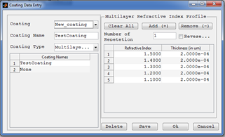

**Purpose:**

A window used to add new, edit and delete existing coating in the coating catalogues used by the optical system.

**Windows Components**

* **Catalogue Popup:** Select the coating catalogue to look for coatings.
* **Coating Name Text Box:** Display name of the coating selected. Or it can also be used to enter a coating name of the new coating to be added.
* **Coating Type Popup:** Display type of the coating selected. Or it can also be used to enter a coating type of the new coating to be added.
* **Caoting List Table:** Display all coating in the current catalogue.
* **Multilayer Refractive Index Profile Panel:** Used to view and edit the parameters of the multilayer caoting selected.
* **Delete:** Deletes the currently selected coating from the catalogue.
* **Save:** Save the coating data entered to current catalogue.

*Created with the Personal Edition of HelpNDoc:* [*Free help authoring tool*](http://www.helpndoc.com/help-authoring-tool)

**Coating Analysis**

**Coating Analysis**

The toolbox supports analysis of multilayer coating. Here coating properties such as transmission and reflection coefficients vs incidence angle and wavelength are included. Coating used in the optical system can be taken by selecting the surface index or a new coating can be analyzed by entering its name directly.

*Created with the Personal Edition of HelpNDoc:* [*Free EPub producer*](http://www.helpndoc.com/create-epub-ebooks)

**Refractive Index Profile**

**Refractive Index Profile**

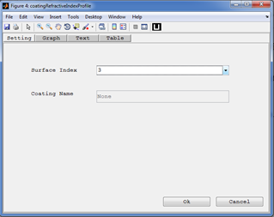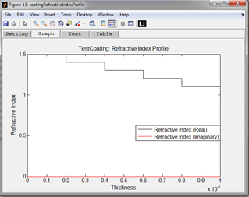

**Purpose:**

Displays the refractive index of a given multilayer coating. The real and complex refractive indices are drawn in different colors in the same graph.

**Setting:**

|  |  |  |
| --- | --- | --- |
| **Settings** | **Description** | **Remarks** |
| Surface Index | The surface index to take and analyze the coating. |  |
| Coating Name | Name of the selected coating. | The coating catalogue containing the coating should be included in the catalogue list of the system. |

*Created with the Personal Edition of HelpNDoc:* [*Write EPub books for the iPad*](http://www.helpndoc.com/create-epub-ebooks)

**Coating Property Versus Incidence Angle**

**Coating Properties vs Incidence Angle**

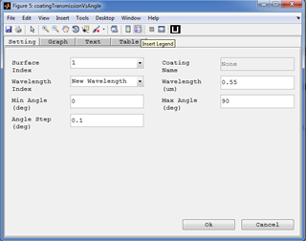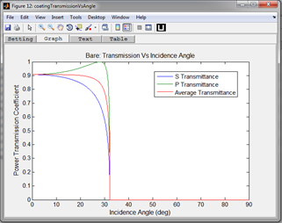

**Purpose:**

* + - **Reflection vs Angle:**

Computes and plots the S, P, and average polarization intensity coefficients for reflection for the specified surface with its coating as a function of incident angle.

* + - **Transmission vs Angle:**

Computes and plots the S, P, and average polarization intensity coefficients for transmission for the specified surface with its coating as a function of incident angle.

* + - **Diattenuation vs Angle:**

Computes and plots the R (reflected) and T (transmitted) diattenuation for the specified surface as a function of incident angle.

* + - **Retardance vs Angle:**

Computes and plots the retardance for the specified surface as a function of incident angle.

**Setting:**

|  |  |  |
| --- | --- | --- |
| **Settings** | **Description** | **Remarks** |
| Surface Index | The surface index to take and analyze the coating. |  |
| Coating Name: | Text box to enter a coating name to be analyzed. | If the New Coating is selected for Surface Index then the user is allowed to enter the coating name. |
| Minimum Angle: | The minimum angle of incidence to plot in degree. This defines the left edge of the plot. |  |
| Maximum Angle: | The maximum angle of incidence to plot in degree. This defines the right edge of the plot. |  |
| Angle Step: | The angle step in degrees for plotting the graphs. |  |
| Wavelength Index: | Index of wavelength to be used from those inserted in system configuration window. |  |
| Wavelength: | Text box to enter a wavelength not defined in the system configuration window. |  |

*Created with the Personal Edition of HelpNDoc:* [*Free EPub and documentation generator*](http://www.helpndoc.com)

**Coating Properties vs Wavelength**

**Coating Properties vs Wavelength**

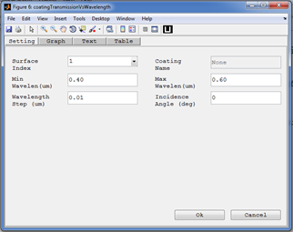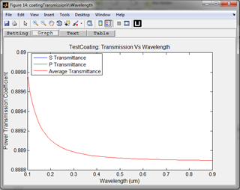

**Purpose:**

* + - **Reflection vs Wavelength:**

Computes and plots the S, P, and average polarization intensity coefficients for reflection for the specified surface with its coating as a function of Wavelength for a given incidence angle.

* + - **Transmission vs Wavelength:**

Computes and plots the S, P, and average polarization intensity coefficients for transmission for the specified surface with its coating as a function of wavelength for a given incidence angle.

* + - **Diattenuation vs Wavelength:**

Computes and plots the R (reflected) and T (transmitted) diattenuation for the specified surface as a function of Wavelength for a given incidence angle.

* + - **Retardance vs Wavelength:**

Computes and plots the retardance for the specified surface as a function of Wavelength for a given incidence angle.

**Setting:**

|  |  |  |
| --- | --- | --- |
| **Settings** | **Description** | **Remarks** |
| Surface Index | The surface index to take and analyze the coating. |  |
| Coating Name: | Text box to enter a coating name to be analyzed. | If the New Coating is selected for Surface Index then the user is allowed to enter the coating name. |
| Minimum Wavelength: | The minimum wavelength (in nm) . This defines the left edge of the plot. |  |
| Maximum Wavelength: | The maximum wavelength (in nm) . This defines the right edge of the plot. |  |
| Wavelength Step: | The wavelength (in nm) step for plotting the graphs. |  |
| Incident Angle: | Text box to enter an incident angle (in degrees) |  |

*Created with the Personal Edition of HelpNDoc:* [*Free Web Help generator*](http://www.helpndoc.com)

**Glass**

**Glass**

In the toolbox the glass parameter could be:

* **FixedIndex:** Defined fixed refractive index, abbe number and partial dispersion.
* **Sellmeir1:** Defined by the six sellmeir coefficients.

*Created with the Personal Edition of HelpNDoc:* [*Easy to use tool to create HTML Help files and Help web sites*](http://www.helpndoc.com/help-authoring-tool)

**Glass Data Editor**

**Glass Data Editor**

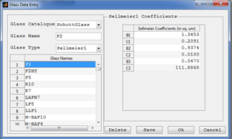

**Purpose:**

A window used to add new, edit and delete existing glass in the glass catalogues used by the optical system.

**Windows Components**

* **Catalogue Popup:** Select the glass catalogue to look for glass.
* **Glass Name Text Box:** Display name of the glass selected. Or it can also be used to enter a glass name of the new glass to be added.
* **Glass Type Popup:** Display type of the glass selected. Or it can also be used to enter a glass type of the new glass to be added.
* **Glass List Table:** Display all glass in the current catalogue.
* **Sellmeir Coefficients Panel:** Used to view and edit the parameters of the sellmeir glass selected.
* **Delete:** Deletes the currently selected glass from the catalogue.
* **Save:** Save the glass data entered to current catalogue.

*Created with the Personal Edition of HelpNDoc:* [*Easily create CHM Help documents*](http://www.helpndoc.com/feature-tour)

**New Glass Catalogue**

**New Glass Catalogue**



**Purpose:**

To create and add a new glass catalogue to the default \CatalogueFiles folder of the toolbox.

*Created with the Personal Edition of HelpNDoc:* [*Produce Kindle eBooks easily*](http://www.helpndoc.com/feature-tour/create-ebooks-for-amazon-kindle)

**Help**

**Help**

The toolbox is well documented and has user manual and programming reference. User manual gives walkthrough of the GUI based usage of the toolbox. The programming reference organized all the detailed commented codes of the toolbox in indexed and interlinked html file format.

*Created with the Personal Edition of HelpNDoc:* [*Free EBook and documentation generator*](http://www.helpndoc.com)

**About**

**About**

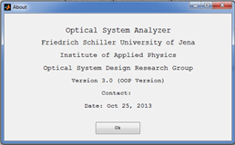

**Purpose:**

Short description about the toolbox.

*Created with the Personal Edition of HelpNDoc:* [*Create HTML Help, DOC, PDF and print manuals from 1 single source*](http://www.helpndoc.com/help-authoring-tool)

**User Manual**

**User Manual**

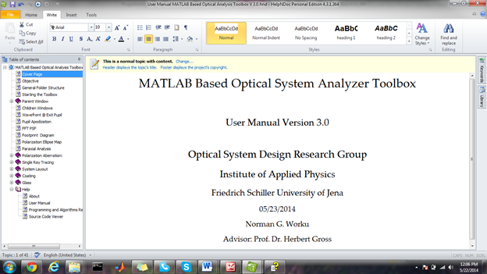

**Purpose:**

Open the electronic form of the user manual.

*Created with the Personal Edition of HelpNDoc:* [*Write EPub books for the iPad*](http://www.helpndoc.com/create-epub-ebooks)

**Programming and Algorithms Reference**

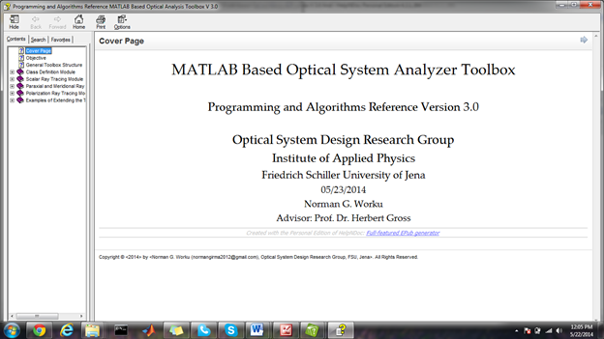

*Created with the Personal Edition of HelpNDoc:* [*Easily create iPhone documentation*](http://www.helpndoc.com/feature-tour/iphone-website-generation)

**Source Code Viewer**

**Source Code Viewer**

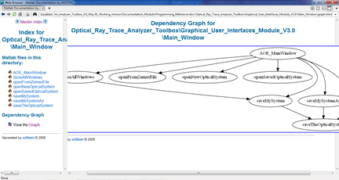

**Purpose:**

Opens an html window which was generated by using a free matlab toolbox called M2HTML [<http://www.artefact.tk/software/matlab/m2html/>]. The html document generated enables users to view and navigate through all functions and class definitions of the toolbox. It also clearly shows function interdependencies in both graphical and hyperlinked text forms. This will have great importance for updating the toolbox as it enables the user to see which other functions are affected by the modification of a given function.

*Created with the Personal Edition of HelpNDoc:* [*Easy EPub and documentation editor*](http://www.helpndoc.com)